TFT-100 tracker to IOT integration documentation

- Revision Number:
Rev. 1.0
- Date of Creation or Update:
22/11/2024
- Prepared By:
M. Sulaiman Shahid (Design Engineer)
Muhammad Sabahat Akhtar(Design & firmware Engineer)
- Reviewed By:
- Approved By:

Table of Contents
- Introduction
- Working Flow Diagram
- Battery IOT Working Details
- Bike IOT Working Detail.
- TFT-100 tracker working details
- Project overview
- Challenges
- Correction approaches
- Algorithm flow
- Key outcomes
- Troubleshooting Guide for TFT-100 Tracker Integration with IoT Systems

1. Introduction
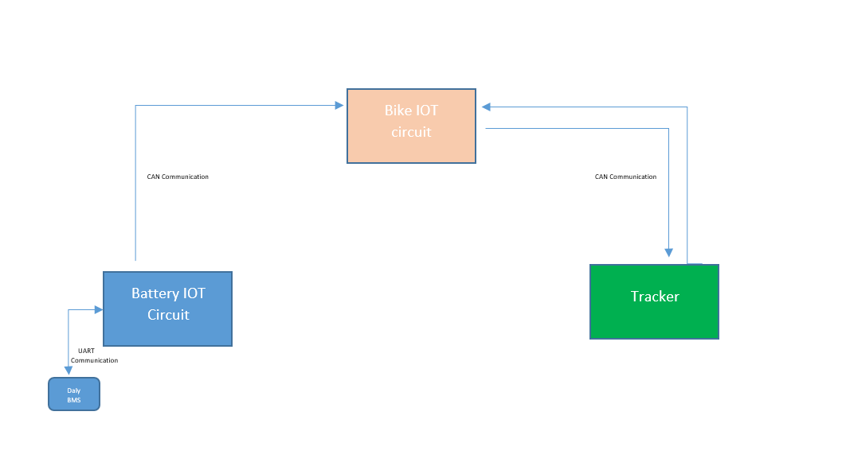
This documentation outlines the integration process of the TFT-100 Tracker with IoT circuits, utilizing CAN Bus communication for data transmission and UART communication for fetching data from the Battery Management System (BMS). The integration aims to enable real-time monitoring and efficient communication between the tracker, the BMS, and the IoT system, ensuring seamless data flow and enhanced system functionality.

2. Working Flow Diagram
Figure1: Workflow chart of battery to tracker communication
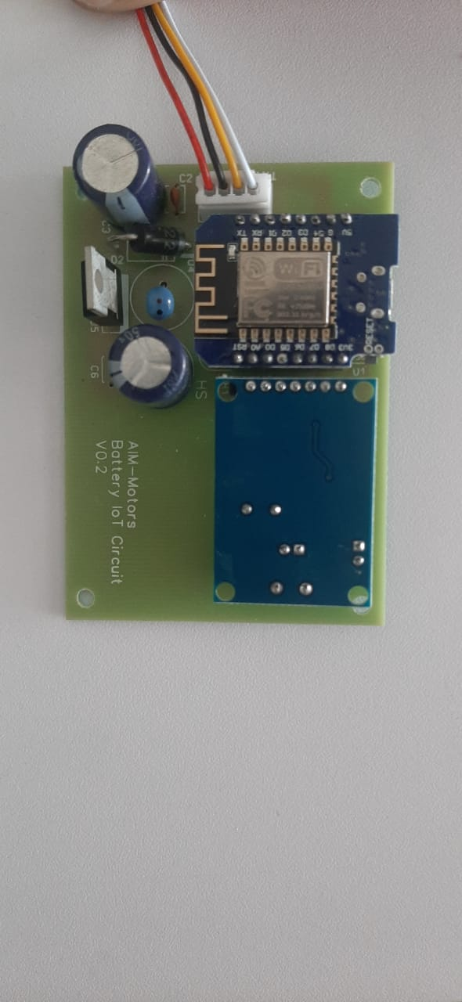
.Battery IOT Working Details
Battery IoT Circuit that retrieves data from the Battery Management System (BMS) using UART communication, processes the data, and transmits it to the Bike IoT system via CAN communication.

Figure2: Battery IoT Circuit

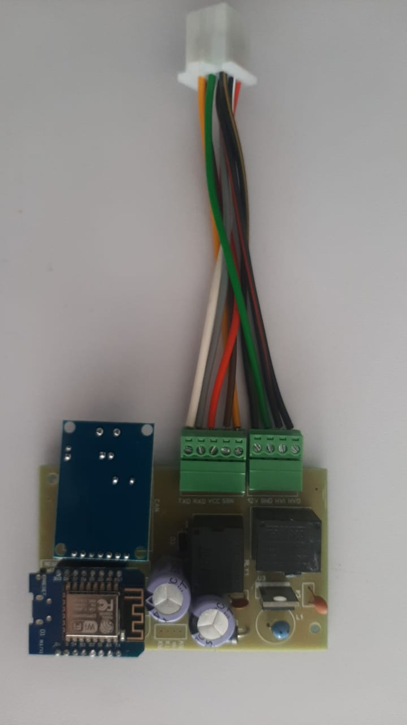
4.Bike IOT Working Details
The Bike IoT Circuit is designed to retrieve and send data from both the Battery IoT system and the TFT-100 Tracker using CAN communication. This circuit facilitates seamless data exchange between the two systems, enabling real-time monitoring of battery parameters and tracking information. The data retrieved from the Battery IoT system includes vital metrics such as voltage, current, and state of charge, while the TFT-100 Tracker provides location and tracking data. Using the CAN communication protocol ensures reliable, high-speed data transmission for both systems, allowing for efficient integration and enhanced functionality within the bike’s IoT ecosystem.
Figure3: Bike Iot Circuit

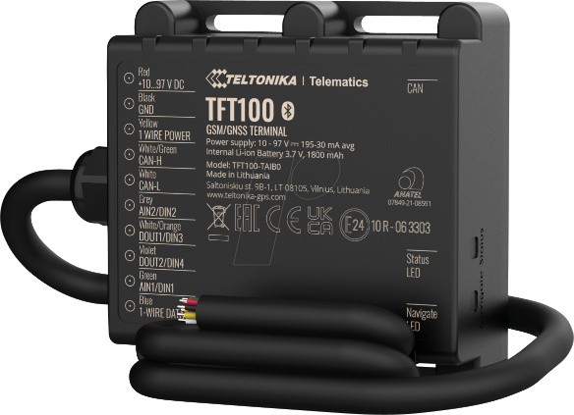
5. TFT-100 tracker working details
The TFT-100 Tracker is a versatile tracking device designed for real-time location monitoring and data logging. It is widely used in applications such as vehicle tracking, fleet management, and IoT-based monitoring systems. Below are the working details of the TFT-100 tracker
Figure 4: TFT-100 Teltonika Tracker

Core Functionality
The TFT-100 Tracker integrates GPS and GSM/GPRS technologies to perform its tracking and data transmission functions. The TFT-100 Tracker also integrates with the Bike IoT system to retrieve parameters of Battery Management System (BMS) from Battery Iot by sending CAN request IDs from the tracker. This integration ensures seamless communication and enables the tracker to fetch vital battery data, such as voltage, current, and state of charge, Individual Cell voltages, Battery Temperature, Battery ID for efficient monitoring and management within the IoT ecosystem.

Key Features
- Real-Time Location Monitoring: Accurate positioning with GPS/GLONASS support.
- Data Storage: Built-in memory to log data when the GSM network is unavailable.
- Alerts and Notifications: Configurable alerts for geofencing, overspeed, low battery, Bike Ignition detection.
- CAN Bus Integration: Supports communication with other systems like Battery IoT or vehicle IoT circuits via the CAN protocol.

Communication Protocols
- GPS Module: Receives signals from satellites for position tracking.
- GSM/GPRS Module: Sends data to the server or IoT platform.
- CAN Protocol: Facilitates communication with onboard IoT systems like Battery IoT or Bike IoT and other Iot circuits which supports CAN protocol.

Wiring Connection of Tracker with Bike Iot

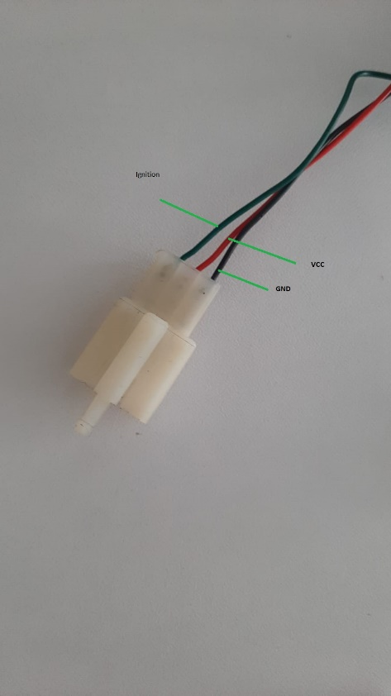
1. Power Input
- Wires:
  - Red (VCC): Connect to the vehicle’s positive terminal (10V - 97V).
  - Black (GND): Connect to the vehicle’s ground or negative terminal.
- Notes:
  - Ensure the input voltage matches the tracker’s specifications (typically 9V–97V DC).

Figure5: Tracker connector

2. CAN Bus Wiring
- Wires:
- CAN-H (High): Connect to the bike Iot CAN bus high line.
- CAN-L (Low): Connect to the bike Iot CAN bus low line
- Functionality:
To enable CAN communication, connect the high-line wire of the bike's IoT system to the tracker’s white/green wire (CAN-H). Similarly, connect the low-line wire of the bike's IoT system to the tracker’s white wire (CAN-L).
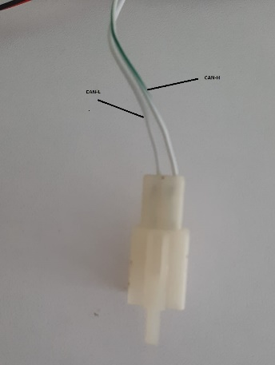
- Notes:
  - Verify the tracker’s CAN configuration matches the Bike Iot CAN bus or (baud rate 250k, ID, etc.).
  - The tracker sends and receives CAN messages to communicate with the IoT system and BMS.
Figure 6: CAN connect

3. Ignition Input (ACC Wire)
- Wire:
(IGN): For ignition detection of bike, connect Green wire (AINT/DINT) of tracker with 12-volt output of key fob or anti-theft system
- Functionality:
  - The ignition input detects when the vehicle is turned on or off.
  - It enables the tracker to switch between active and sleep modes based on the ignition status.
- Notes:
  - Use a diode or relay to prevent reverse current flow if necessary.
  - Ensure the ignition input voltage does not exceed the tracker’s specified limit (12V-25V)

4. Digital/Analog Inputs
- Wires:
  - Input 1 (Digital/Analog): Connect to a sensor or input device (e.g., door status, SOS button).
  - Input 2 (Digital): Can be used for additional monitoring (e.g., brake signal or auxiliary device).
- Notes:
  - Analog inputs can read voltage levels, while digital inputs detect on/off states.
  - Verify voltage compatibility for connected sensors or devices

5. Digital Outputs
- Wires:
  - Output 1 (Relay Control): Can be used to control external devices (e.g., fuel pump, starter relay).
- Functionality:
  - Outputs can drive relays or external circuits for vehicle control functions.
  - Typically open-drain outputs that require external power sources to drive loads

6. Project Overview
The goal is to integrate bike IoT functionality with the TFT-100 Tracker while fetching battery data from a Daly BMS (R25T-HJ06). The project encountered challenges due to power leakage faults and communication inefficiencies. The solution evolved through several correction approaches

7. Challenges
- UART Port Faults:
External power leakage through the bike Iot to the Daly BMS UART port caused recurring faults.
- CAN Limitations:
  - Daly BMS’s CAN port does not provide individual cell voltages.
  - The existing CAN library in the ESP8266 microcontroller supports only data reception, not transmission to the tracker.
- ESP-NOW MAC Dependency:
  - Initial fixes using ESP-NOW worked, but the MAC address-based pairing is unsuitable for large-scale deployment due to manual configuration requirements.

8. Correction Approaches

1. Using the Daly CAN Interface (Initial Fix)
- Problem: Individual cell voltages were unavailable from the Daly BMS via CAN.
- Outcome: Limited functionality; didn’t meet the project requirements.

2. Updating the CAN Library
- Introduced a new CAN module library capable of both fetching data and transmitting requests via Request IDs.
- Problem: Firmware update and integration required significant development time, missing project deadlines.

3. Implementing ESP-NOW Communication (Temporary Fix)
- Utilized ESP-NOW to wirelessly communicate data between the Battery IoT (slave) and the Bike IoT (master).
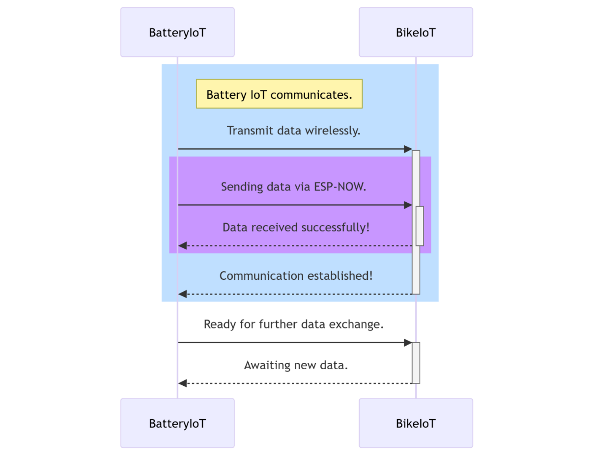

- Data Flow:
  - Battery IoT fetched data from Daly BMS via UART.
  - Transmitted data wirelessly using ESP-NOW.
  - Bike IoT sent data to the tracker via its CAN module.
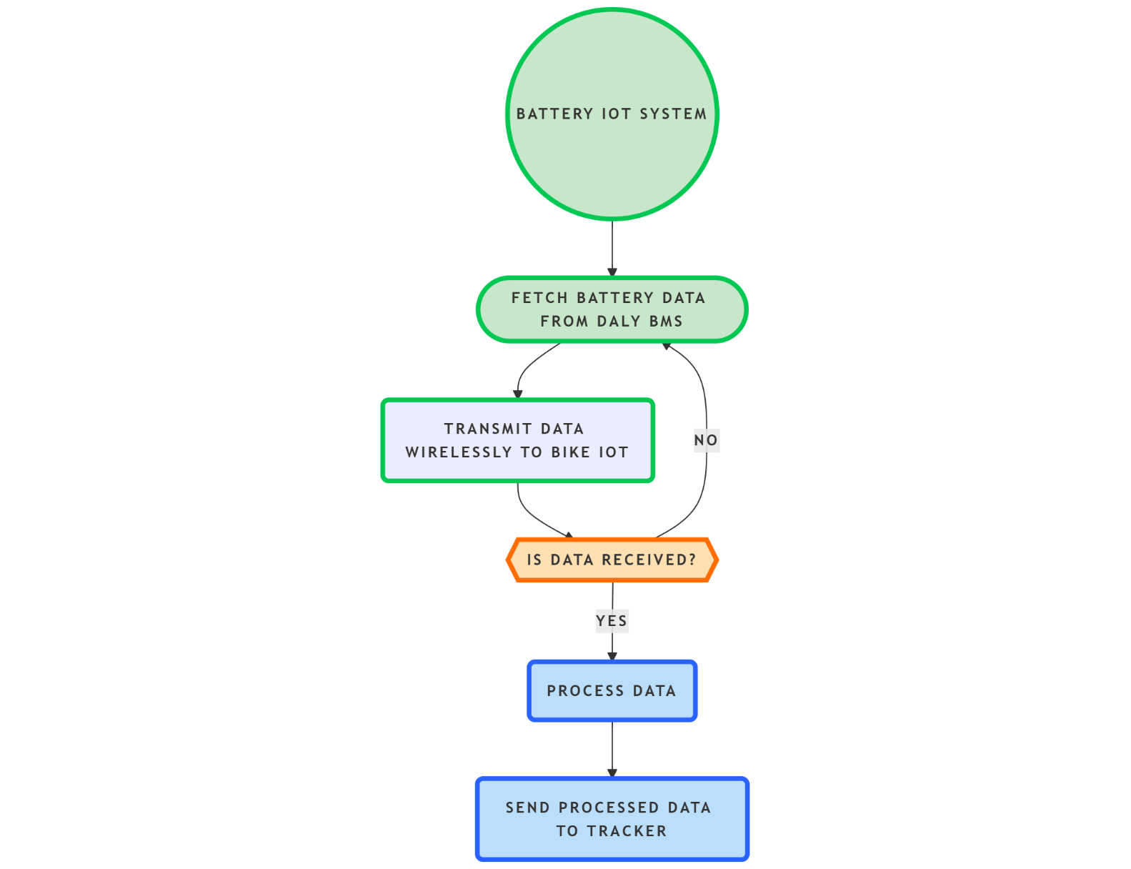
- Drawback: ESP-NOW relies on MAC address pairing, leading to scalability challenges in large-scale deployments.

4. Final Solution: Dynamic Battery Data Retrieval with Updated CAN Library
- Worked on the new CAN library to enable dynamic data fetching and transmission from the Battery IoT, eliminating MAC dependency.
- Designed an algorithm to manage dynamic communication, allowing seamless integration of Battery IoT and Bike IoT irrespective of their MAC addresses.

9. Algorithm Flow
- Battery IoT:
  - Fetches data from the Daly BMS UART port.
  - Transmits the data via its CAN module to Bike IoT.
- Bike IoT:
  - Receives data through its CAN module.
  - Processes and forwards data to the tracker system Via CAN.
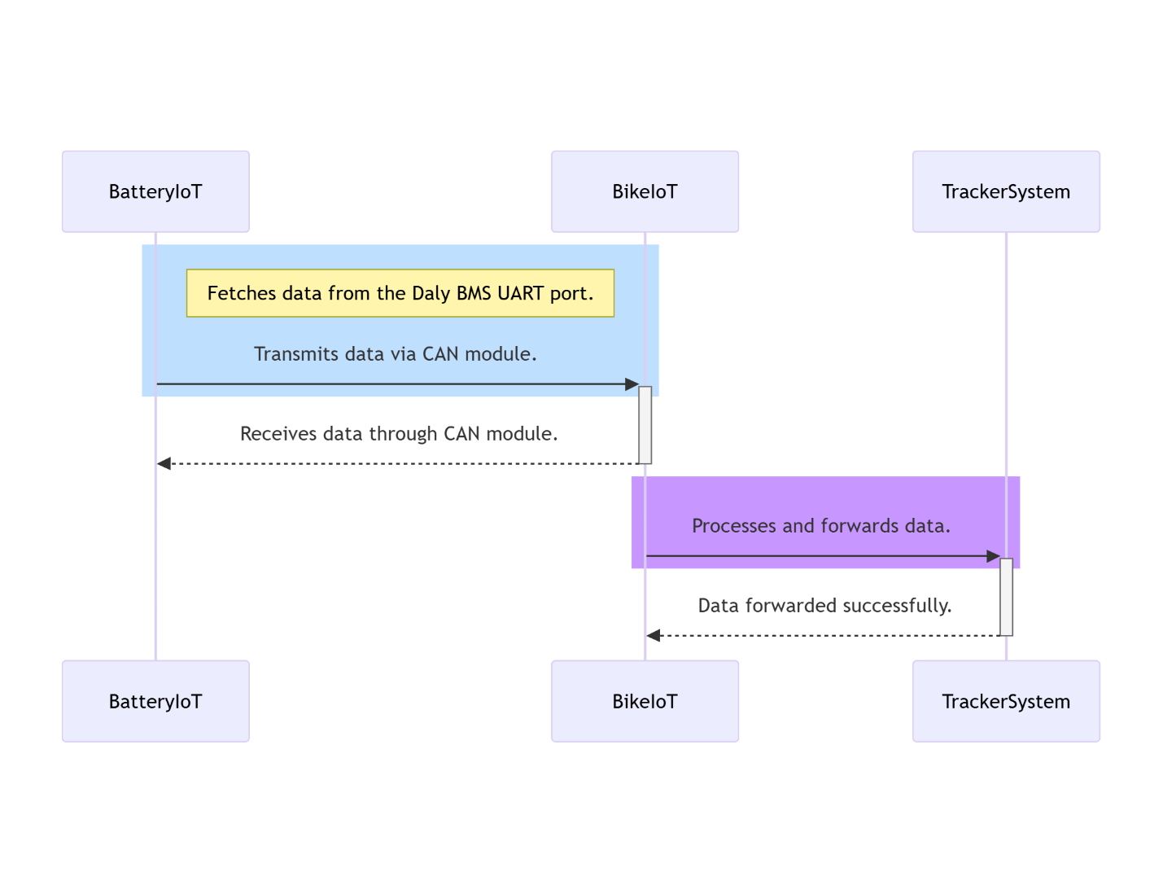

10. Key Outcomes
- The final solution ensures:
  - Scalability for large-scale deployment.
  - Dynamic and seamless communication between IoT devices.
  - Elimination of manual MAC address configuration.
  - This algorithm serves as a robust framework for future projects involving battery data tracking and IoT integration.

11. Troubleshooting Guide for TFT-100 Tracker Integration with IoT Systems
This troubleshooting document provides a structured approach to identify, diagnose, and resolve issues in the integration of the TFT-100 Tracker with IoT systems, which includes Battery IoT and Bike IoT circuits.
Issue | Possible Cause | Affected Component
UART communication failure | Power leakage through the bike to Daly BMS UART port. | Battery IoT
Data not received via CAN | Incorrect CAN configuration or mismatched baud rates. | Battery IoT, Bike IoT, Tracker
Missing battery cell data | Daly BMS CAN protocol does not transmit individual cell voltages. | Daly BMS, Battery IoT
ESP-NOW connection drops | MAC address dependency or interference in wireless communication. | Battery IoT, Bike IoT
Tracker not powering on | Incorrect wiring of power input or mismatched voltage specifications. | TFT-100 Tracker
CAN communication failure | Loose connections or incorrect wiring for CAN-H and CAN-L lines. | Battery IoT, Bike IoT, Tracker
Ignition detection failure | Incorrect connection of ignition input wire or faulty relay setup. | Tracker

2. Diagnostic Steps
Step 1: Verifying Power Supply
- Action: Check the voltage at the tracker’s power input terminals.
  - Ensure the voltage is within the range of 10V to 97V.
  - Inspect for loose connections or damaged wiring.
- Resolution: Fix wiring issues or replace damaged components.
Step 2: Checking UART Communication
- Action: Use a serial monitor to verify data transmission from the Daly BMS to the Battery IoT.
  - Confirm that the UART port on the Daly BMS is functional.
  - Check for power leakage causing port failures.
- Resolution: Add isolation circuitry to prevent power leakage.
Step 3: Verifying CAN Communication
- Action: Inspect CAN-H and CAN-L connections between all devices.
  - Use a CAN analyzer to check message transmission and reception.
  - Verify the baud rate and CAN IDs match across all devices.
- Resolution: Reconfigure baud rates and CAN IDs. Ensure proper termination resistors are in place.
Step 4: Testing ESP-NOW Functionality
- Action: Monitor ESP-NOW communication logs for successful pairing and data transmission.
  - Ensure both devices (Battery IoT and Bike IoT) have correct MAC addresses configured.
  - Check for wireless interference.
- Resolution: Update firmware to dynamically fetch MAC addresses or switch to a more scalable communication protocol.
Step 5: Tracker Diagnostics
- Action: Check tracker LEDs for status indications (power, GPS, GSM, and CAN).
  - Confirm GPS and GSM modules are operational.
  - Verify tracker CAN configurations match the Bike IoT settings.
- Resolution: Reconfigure tracker settings using its configuration tool. Replace damaged components if needed.
Step 6: Ignition Detection
- Action: Measure voltage at the ignition input wire when the bike is turned on.
  - Check diode or relay connections to prevent reverse currents.
- Resolution: Correct wiring issues or replace faulty relays.
3. Wiring Inspection Checklist
Connection | Inspection Point | Status
Battery IoT UART to Daly BMS | Confirm secure connection and proper baud rate configuration.
Battery IoT CAN to Bike IoT | Verify CAN-H and CAN-L lines are correctly connected.
Bike IoT CAN to Tracker | Check for termination resistors and proper wiring of CAN lines.
Tracker Power Input | Ensure voltage is within specified range (10V - 97V).
Ignition Input Wire | Confirm correct voltage detection and proper relay setup.
Error | Resolution
No data on UART | Check for power leakage, use isolated UART circuits, and verify Daly BMS settings.
Incomplete CAN messages | Reconfigure CAN IDs, ensure baud rates match, and verify termination resistors are in place.
ESP-NOW pairing failure | Implement dynamic MAC address retrieval or check for wireless interference.
Tracker not logging data | Inspect tracker configuration, ensure sufficient GSM signal, and verify memory functionality.
GPS location not updating | Relocate tracker for better satellite visibility and check GPS antenna connection.
Ignition not detected | Replace faulty relay or diode; ensure voltage from the ignition wire is within acceptable range.

4.Error Resolution Techniques

This troubleshooting guide should assist in resolving integration issues effectively, ensuring reliable operation of the IoT ecosystem.

